A Protocol for the Basic Tissue culture of Cannabis sativa L.
By: Faith Ann Sparks, 2022
Cornell University

Protocol Overview:
- Explant Collection, Preparation, and Induction
- Sterilization
- Media Composition & MS Vitamins Recipe Templates
- Acclimatization
- Best Practices
- In-Vitro to Ex-Vitro Workflow chart
- References
Abbreviations:

CaCl: Calcium Chloride
ddH₂O: deionized, distilled H₂O
DLI: Daily light integral
EDTA: Ethylenediaminetetraacetic acid
FeEDTA: Iron + EDTA (chelated iron)
KPO₄: Potassium Phosphate
MgSO₄: Magnesium Sulfate
μmol m⁻²s⁻¹: micromole per meter squared per second
MS: Murashige and Skoog
NH₄NO₃: Ammonium Nitrate
RH: Relative humidity
UV: Ultra violet

- Explant Collection, Preparation, and Induction:

- Choose unlignified, young, vegetative, preferably axial nodal tissue as explants for in-vitro propagation (Fig. I).
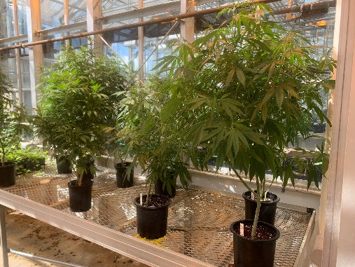
- Selectively cut the stem on an angle above a node to preserve structural integrity of the stock plant.
Figure I Stock plants kept under long day photoperiod of 18 hours of HPS light at 25-28°C and 65% RH.
- Take cuttings from lateral branches and leave the most apical shoots on the stock plant.
- Be sure to consider the direction of the apical node left on the stock plant to encourage growth in the direction most conducive to your growing environment (Fig. I).
- Be sure to take cuttings that have at least three-six meristematic nodes and are 4-6” in length (Fig. II.a).
- Always use clean and sharp shears.
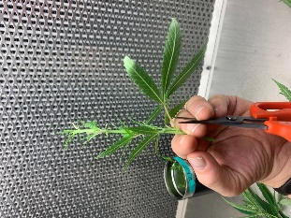
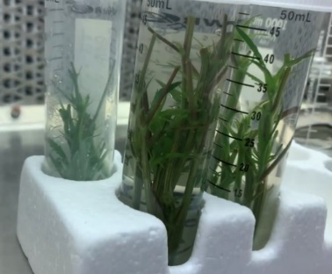
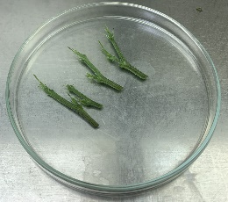
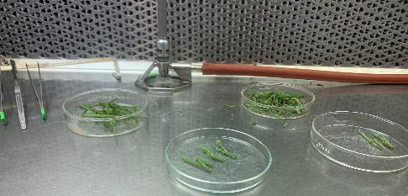
- Work from cleanest facilities to most infected to reduce pathogen spread.
Figure II Cuttings after surface sterilization (a), A cutting being processed to remove excess tissue prior to sterilization(b), explants ready to be placed in sterile media (c), Example of under-the-hood organization for aseptic technique (d).
b
a
d
c
- Clean shears with ethanol if possible before moving on to the next plant.
- Avoid taking cuttings from any visibly infested plants. Modify sterilization procedure to accommodate pest pressure.
- Remove all fan leaves at least ½-1 inch from the stem leaving the length of the petiole (this will serve as a protective measure for the meristematic tissue against the destructive effect of the ethanol, bleach, and mechanical agitation used in the sterilization process (Fig. II.b)
- Place basal end of the cutting in clean water. Enclose the container if possible. Return nodal tissue to the laboratory as quickly as possible.
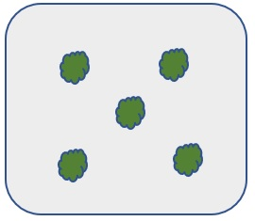
- When transporting fresh cuttings, it is helpful to place the vessels in a cooler with ice to maintain the cuttings’ freshness as well as to halt bacterial growth at the cut sites prior to sterilization and in-vitro induction but this is not necessary for successful explant initiation.
Figure III A graphical view of a culture vessel from above with a suggested explant placement for in-vitro micropropagation of hemp.

- Always ensure the cuttings’ basal ends are placed in vessels containing water for transport back to the laboratory. Plants will not survive the sterilization procedure if they have lost too much turgor pressure.
- It is best to sterilize and induct cuttings in-vitro within hours of sample collection, but it is possible to hold the fresh cuttings at 4ºC with ample relative humidity overnight if necessary. Do not sterilize cuttings prior to storage if they are to be held at 4ºC but do remove all foliage to reduce transpiration and to conserve space.
- Sterilize cuttings directly proceeding in-vitro induction after overnight storage.
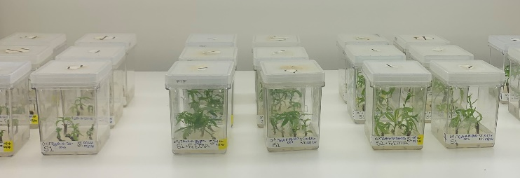
- After sterilization, further separate meristematic groupings and remove damaged tissue with a sterile sharp scalpel so that each explant has about two meristematic buds per 2” of stem under a flow hood in a sterile environment with sterile tools (Fig. II.c).
Figure IV Differing arrangements or vessels may be used depending on the environment of demands of the cultivation system. Pictured are standard GA-7 Magenta-type boxes.

- Place explants in media in the pattern shown in (Fig. III).
- Replace vessel lid and place vessel in low light environment at 28◦C and 24-hour light.
- Gradually increase the PAR to 50-90umol m⁻²s⁻¹ over the course of a week, (Fig. IV).

- Sterilization:

- Spray down work surface with at least 70% ethanol and allow to dry.
- If available, use a UV light to reduce the population of additional microbes. Some would say this is unnecessary, however, it is the technician’s preference. UV light will damage plant tissue so do not leave plant tissue exposed to UV light.
- Sterilize all tools with flame or other heat source and use sterile glass plates for a cutting surface. The recommendation is to use 125mm glass Pyrex dishes wrapped with aluminum foil and lined with sheets of 125mm Whatman paper. Autoclave for 20 minutes with a 20-minute dry cycle or comparable cycle to ensure sterility.
- If desired or necessary, bring microscope into flow hood as cleanly as possible.
- Submerge cuttings in 70% ethanol and seal the vessel under the flow hood. Apply gentle agitation for a duration of 2-2.5 minutes. Be sure to provide wiggle-room for the cuttings to be adequately sterilized on all surfaces. It is recommended to use 50mL conical vials for these submersion steps.
- Drain away the ethanol and rinse the cuttings once with sterile ddH₂O.
- Submerge the cuttings in 0.75-1.25% sodium hypochlorite (dependent on hemp variety and level of pathogen/pest present on the stock plant tissue) supplemented with 1-2 drops of tween per 100mL of bleach solution as needed (i.e. If there was a recent spray in the greenhouse or if there is substrate present on the plant tissue). Seal the vessel and apply gentle (<50rpm) agitation for ten minutes.
- Immediately drain away the bleach/tween solution and rinse five or more times with sterile ddH₂O until the smell of bleach is no longer detected and there is no more sodium hypochlorite left on the plant tissue.

- Media Composition & MS Vitamins Recipe Templates:

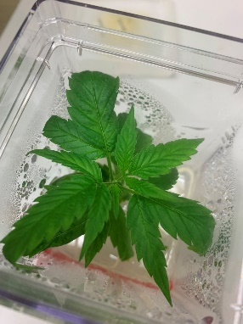
Figure V A C. sativa L. plantlet from tissue culture ready to acclimate into the greenhouse.
- Acclimatization:

- Remove the vessel lid and pour clean and/or sterile H₂O (approx. 50 mL) on the media.
- Replace the covering ajar.
- Change the water once or twice per day for three days and allow the vessel closure to be increasingly open each day (Fig. V).
- Pull plantlet out of the media and gently remove excess media on the roots.
- Plant the rooted plantlet in LM-111 premoistened soil mix and water in with clean water.
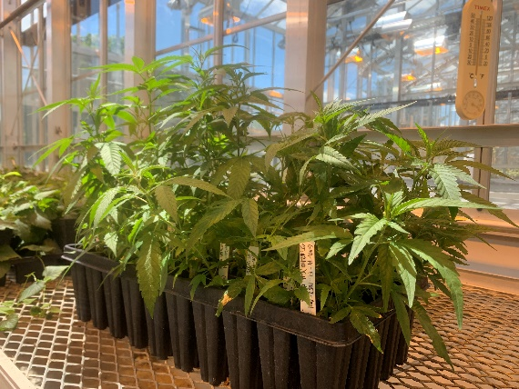
- Cover the tray with a tall dome and keep humidity high within the dome.
Figure VI Hemp plants from tissue culture after acclimatization
- Place in a cool (but not less than 25°C) spot of the greenhouse out of direct light for one week and maintain humidity and circulation consistently (avoid spikes and dips in RH and for photoperiod sensitive plants maintain vegetative growth with short nights and long days dependent on genotype).
- Remove the dome when new growth begins to appear in approx. one week (Fig. VI)
- Plantlets have survived omissions of the first four steps in this section, but acclimatization success rate is higher when a gradual humidity acclimatization is performed.

- Best Practices:

- Upon tissue collection, try to keep the humidity high in the transfer vessel and avoid direct light or heat as these abiotic stressors may influence turgor pressure and make the cuttings more susceptible to unreconcilable damage.
- Always give newly inducted tissue a gradual introduction to high light environments. The reduction of shock is necessary after the sterilization procedure.
- Never leave visibly damaged tissue on the cuttings after sterilization.
- It is best to make media prior to tissue collection.
- Use best judgment when transferring tissue early in-vitro and allow time and labor to be spent removing dead and dying tissue.
- Always truncate cuttings to two-three nodes per explant, and discard the most apical node.
- Be sure your scalpels, forceps, and tool rests are all sterile and cooled to room temperature before allowing them to encounter sterile plant tissue, (hot tools cause unreconcilable damage to the delicate plant tissue and should not be used to handle the explants).
- The author suggests using #10 blades and developing a cutting technique that leaves cleaner cut sites.
- If there is any doubt the sterile explant has touched an unsterile surface discard explant immediately and re-sterilize the tool it is not worth contaminating a whole box or the rest of the sterile plant tissue.
- Do not overcrowd explants in the vessel if you can avoid it or the shoots will develop etiolated tissue that cannot be easily acclimatized back to the greenhouse, it is best to provide adequate space for shoots to receive a sufficient DLI.
- Whenever possible, chose to use ventilated culture vessels. Providing sufficient gas exchange allows the tissue to develop more normally (i.e.. not hyperhydric or vitrified) and saves time and resources throughout the process. Keep in mind ventilated lids make the cultures more susceptible to pathogen invasion. Adjustments to transfer schedule may be necessary depending on the system and biological demands.
- Sow initial cultures onto Hemp TC media for one week up to one month depending on the number of transfers that are necessary in early explant induction to eliminate persistent endogenous microbial populations or lingering contaminants.
- Long-night genotype cultures can be maintained on Hemp TC media indefinitely under a 24-hour photoperiod at approx. 50-90umol m⁻²s⁻¹ at 28ºC without flowering. Not all varieties of hemp are well suited to this environment, though and this may differ according to photosensitivity of the genotype, adjust lighting as necessary.
- Depending on contamination levels, cultures may require additional sterilization procedures throughout the cultures’ in-vitro lifespans. It may be necessary to shorten the length of time between subcultures to reduce the pressure of the contaminant.
- In some instances, the most efficient course of action is discarding the contaminated cultures. To account for this potential loss it is recommended to take approx. 10% more tissue at explant induction and discard cultures that contain persistent contamination.

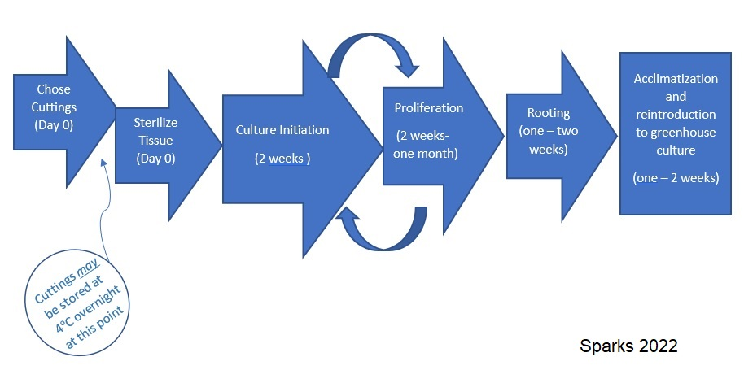
- In-Vitro to Ex-Vitro Workflow Chart
Figure VII Workflow-chart of a typical hemp tissue culture project. Components should be adapted to the environment and genotype for healthiest propagules.

- References
Hesami M, Adamek K, Pepe M, Jones AMP. Effect of Explant Source on Phenotypic Changes of In Vitro Grown Cannabis Plantlets over Multiple Subcultures. Biology. 2023; 12(3):443. https://doi.org/10.3390/biology12030443

Jessica D. Lubell-Brand, Lauren E. Kurtz, Mark H. Brand. An In Vitro–Ex Vitro Micropropagation System for Hemp. HortTechnology. 2021;31(2):199-207. doi:10.21273/HORTTECH04779-20

Peterswald TJ, Mieog JC, Azman Halimi R, Magner NJ, Trebilco A, Kretzschmar T, Purdy SJ. Moving Away from 12:12; the Effect of Different Photoperiods on Biomass Yield and Cannabinoids in Medicinal Cannabis. Plants. 2023; 12(5):1061. https://doi.org/10.3390/plants12051061

Stephen, C., Zayas, V. A., Galic, A., & Bridgen, M. P. (2023). Micropropagation of Hemp (Cannabis sativa L.), HortScience, 58(3), 307-316. Retrieved Mar 15, 2023, from https://doi.org/10.21273/HORTSCI16969-22

Wang M-R, Bettoni JC, Zhang A-L, Lu X, Zhang D, Wang Q-C. In Vitro Micrografting of Horticultural Plants: Method Development and the Use for Micropropagation. Horticulturae. 2022; 8(7):576. https://doi.org/10.3390/horticulturae8070576

